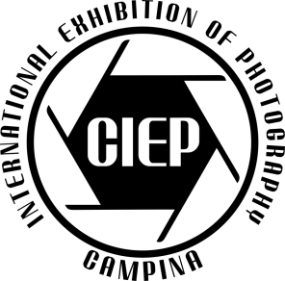
PSA: 2025-1897 GPU: L250079
10th CAMPINA 2025
INTERNATIONAL EXHIBITION OF PHOTOGRAPHY, ROMANIA
ENTRY FORM

Given Name: Family Name:
Honoros: Photo Club:
Address:
City: Zip Code: Country:
Email:

Color Open Section: Monochrome Open Section:
1. 1.
2. 2.
3. 3.
4. 4.

Photo Travel General Section: Photojournalism General Section:
1. 1.
2. 2.
3. 3.
4. 4.

Nature General Section:
1.
2.
3.
4.

“I hereby confirm that I have read and understood and agree to the Conditions of Entry of this exhibition. I have read and understood the PSA document to be found here: https://psaphotoworldwide.org/resource/resmgr/pdf/exhibitions_/exhibition-entrants-agreemen.pdf.
I am aware that PSA may apply penalties for non-compliance to these Conditions of Entry”
Failure to agree will mean that the application will not proceed.

Date: Signature:

